Meeting the Brief (400 words - 27 marks)
Video - Write your Script below

BR 1-

BR 2-

BR 3-

AR 1-

AR 2-

AR 3-

Investigation (400 words - 10 marks)
Evidence of research on the brief
- Pick 3 possible data and state why you picked them
- Select one data set and state why you picked this

Possible Datasets:
Air And Sea Travel WorldWide
I picked this dataset as I am interested in transport, especially in airports. This dataset contains data about the amount of people leaving and arriving in Ireland from 2010 until 2023 and the country. However only a LIMITED amount of countries is inputted into the dataset.

Overseas Trips To Ireland
Like the previous dataset, I chose this data since it's based on transport. The dataset shows information on the amount of people coming from overseas into Ireland. However, like the previous dataset, the amount of countries that are named are very LIMITED and the dates of when the values were recorded are difficult to READ.

Tourism Dataset Worldwide
I am curious about the tourism sector which is why I picked this dataset. From this dataset I was able to learn about the amount of revenue earned from certain locations throughout the whole world. But the flaws identified is that the date of each data is NOT recorded and the locations are NOT identifiable.

Chosen Dataset:
Passengers Handled By Irish Airports
I chose this dataset as I found it to be the best suited based on the area that I am interested in ( Transport / Tourism ).This dataset contains the values of passengers coming to and leaving from Irish airports. The dates are clearly labelled, monthly, from 2019 until 2024 that will make detailed graphs for analysis.

One thing that I have to look at is that the value from Dublin airport is far greater than the rest of the airports which makes it difficult to read the overall graph. The total values are also recorded monthly so I will find ways to exclude these for alternate graphs.

Evidence of research of existing solutions/systems of an interactive information system that can inspire your project
- Is there any system currently (Weather app etc) out there
- If there is another system, how will yours be different

Other than official airport apps, like Dublin Airport and Shannon Airport, that only show information on future flights. There is no existing app that showcases the amount of passengers being handled.

However I was able to find a website created by CSO which shows information based on the amount of passengers handled throughout the years from Irish airports. It displays the information in texts and in graphs.

My system will use different graph types and information to display onto my system. I will make the overall presentation of the system distinct from the CSO website.

References - any links that you have looked at, please past them here or you will forget them at a later stage

CSO Website ( Existing Solution ).

Dublin Airport App

Shannon Airport App

https://www.kaggle.com/datasets

https://data.gov.ie/dataset/

—-

https://www.geeksforgeeks.org/how-to-drop-one-or-multiple-columns-in-pandas-dataframe/
https://www.w3schools.com/python/pandas/default.asp

3.Plan and Design (400 words - 15 marks)
Clearly describe the design of the project
- What will it do?
- How will it do it?
- What will be the inputs and outputs?

My project will be designed to display information and graphs based on my chosen dataset. The user will be able to navigate and interact with the system, and view all the necessary information.

To achieve this, I will use HTML, CSS, and JavaScript to create a presentable system to the user. Python will be used to perform dataset analytics which will form graphs that will be presented onto the system. It will be used to extract and store specific information.

How will your project meet the brief requirements
- Use the language of the brief here

BR 1- After finding a suitable dataset from a reliable source, I will use Python to clean the dataset from unnecessary information and make it easier to use.

BR 2- Using Plotly in Python, graphs can be generated with the dataset variables. I will analyse each graph and ensure all labels are correctly placed. I will use functions to find key values, like Max, Mean, Median, etc. which I will store into a dictionary.

BR 3- On VSCode, I will use HTML to input information and visualisations onto the system, and CSS to design the appearance. JavaScript will be used to make the system interactive and dynamic.

AR 1- Using Plotly in Python, I can make the graphs to be interactive by allowing the user to highlight legends and hover for details, including an animated graph.

AR 2- Using JavasScript, I will present a form that will ask the user questions on at least 3 different data types. The data will be checked for abnormalities and stored. The summarised data will then be displayed through the system.

AR 3- By creating a separate HTML file, I will display information based on what I’ve learned from analysing my dataset, then my recommendations at the bottom.

What technologies did you use, how and why- Fully explain each of them

- I used a computer to access the data I have chosen and to develop the code needed for my requirements.

- Python was my primary programming language for this project. I chose Python because it is capable of using a variety of libraries for data analysing and visualisation, such as Plotly and Pandas, and its suitability for web development.

- VS Code was used as my web development platform. This allowed me to use HTML, CSS, and JavaScript. HTML and CSS allowed me to input my information and visualisations on my system and make them look presentable to the users. JavaScript added interactive features to the system and handled validation of the form inputs, ensuring good quality data.

Detailed flowchart - Start to finish of the project - This can be more than one

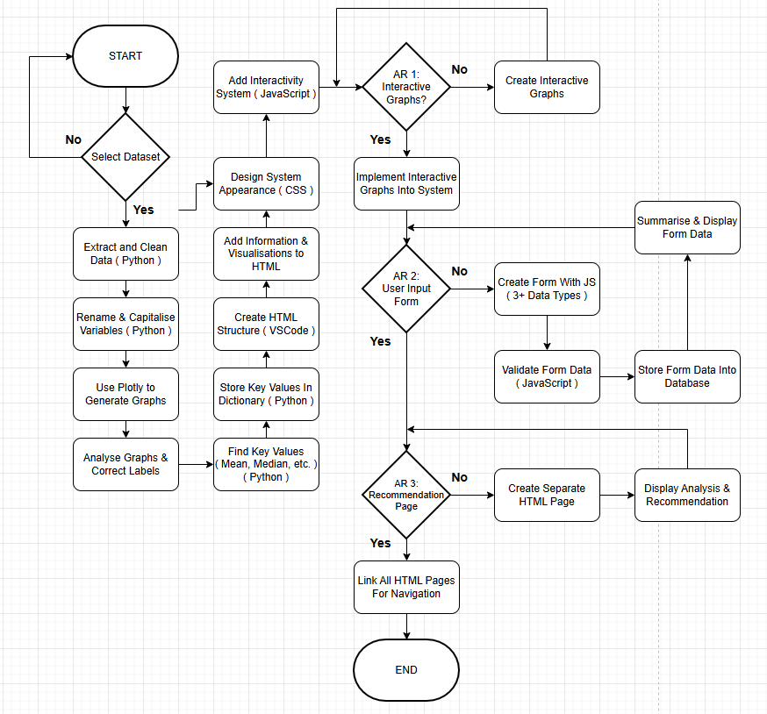

Wireframe for your plan of the layout of the website - How will you meet the universal design principles - Have you got good user interface, if so explain

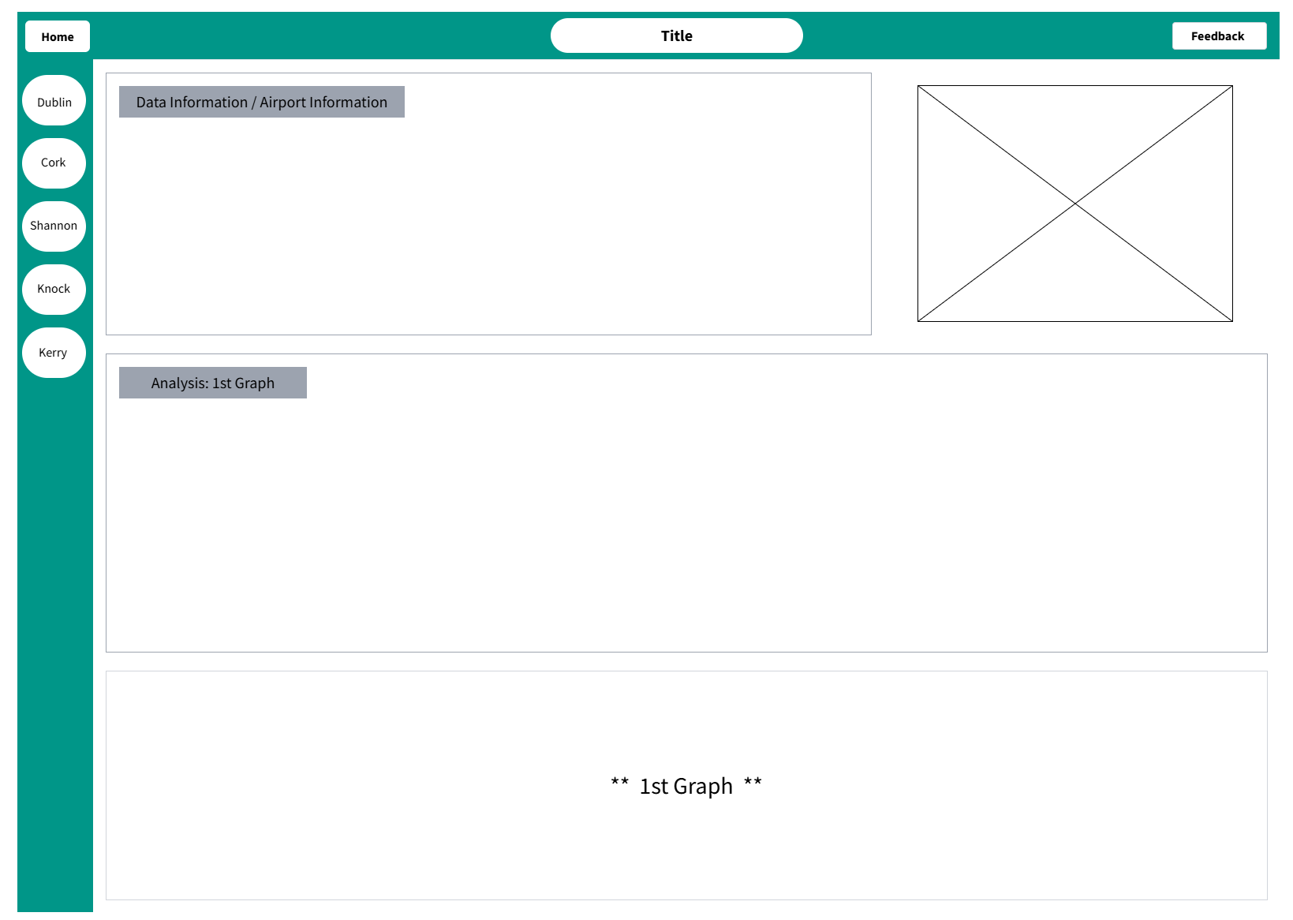
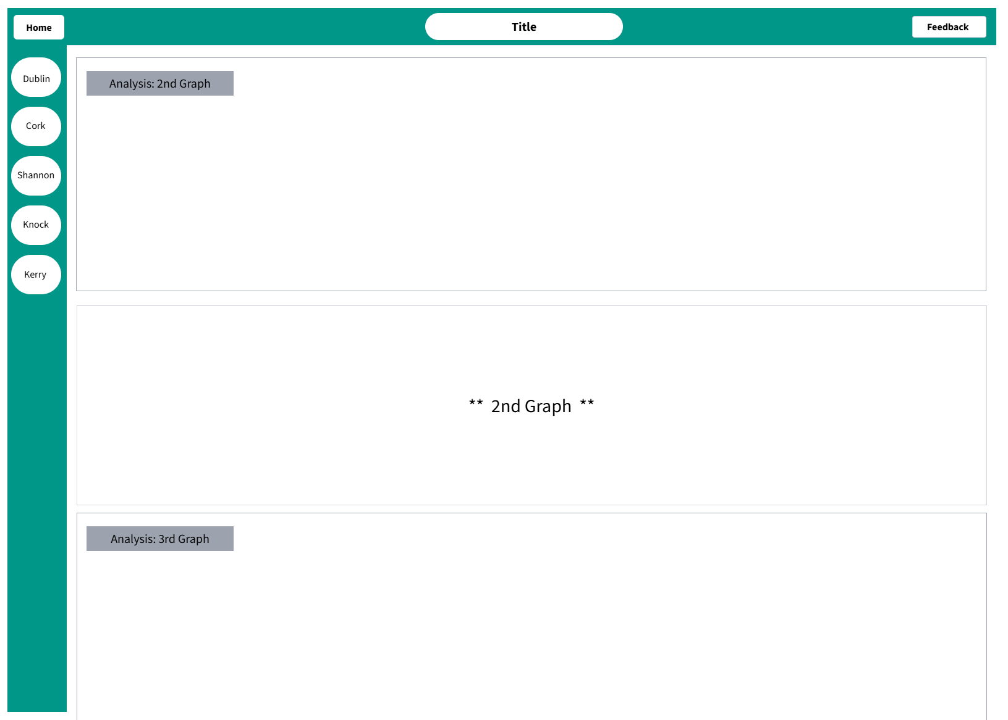
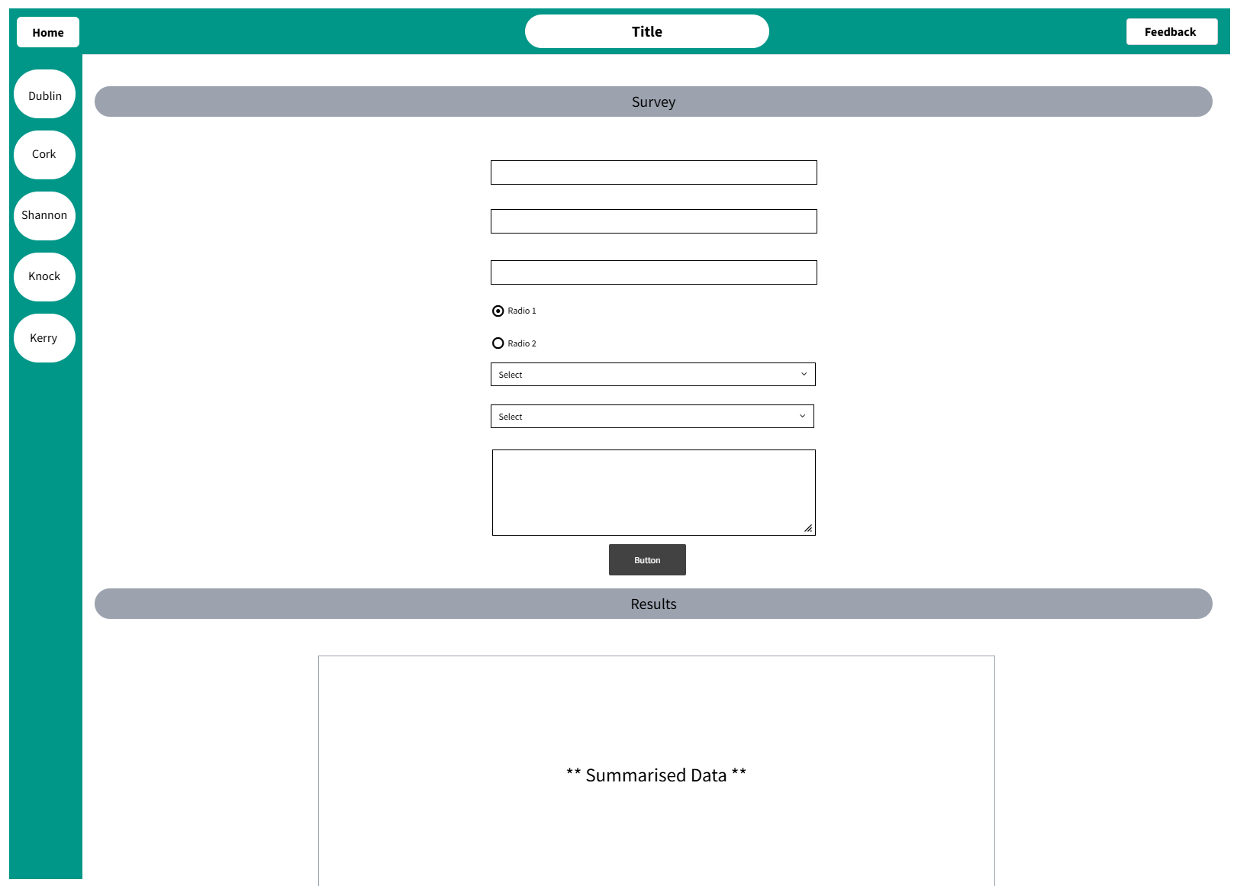

- Equitable Use - Users can view different types of graphs and interact with them to gain different perspectives.
- Flexibility in Use - A clear navigation bar will be provided on the page at all times to help users easily find their way around the website.
- Simple and Intuitive Use - A consistent layout will be maintained throughout all the pages to provide a predictable user experience.
- Perceptible Information - Easy to read fonts and wide spacing are used to avoid visual clutter and improve readability.
- Tolerance for Error - A pop-up will appear that will provide a specific message on the question you missed on the form.
- Low Physical Effort - The navigation menu provided will be clear and easy to use, reducing the need for excessive mouse movements or clicks.
- Size and Space for Approach and Use - The size of the visualisations and font sizes change with page size ensuring enhanced readability.

I believe I have a good user interface as I have taken into consideration every Universal Design Principle while I was designing my website.

4. Create (1000 words - 25 marks)
Include a progress log - make sure it includes a key milestone - something significant you did each week or a problem that you have overcome

Week 1 & Week 2 | I researched different datasets from a variety of sources. I selected possible datasets that interested me and looked into it. I chose the most suitable dataset that I will use for my project.
Week 3 | I started cleaning my dataset by removing unnecessary data and renaming variables and capitalising them. I generated a variety of useful graphs, such as a line graph and pie chart.
Week 4 & Week 5 | However, a problem occurred with my bar graphs. I came up with a solution and used it for my problem section. This saved me a lot of time. I successfully generated presentable bar graphs for each airport.
Week 6 & Week 7 | I completed the last part of BR 2 by coding Functions to find the Highest Value, Mean, Median, and Range of each airport and storing them into a dictionary in Python. I created a wireframe layout for my information system. I completed AR 1 by making an animated bar graph and a pie and line graph that is interactable.
Week 8 | I completed the main wireframe layout of my information system using HTML and CSS. I converted the graphs into a suitable file format using Python that allows me to present them on my information system.
Week 9 | I created and linked each airport HTML file using JavaScript. I inputted the graphs and wrote my analysed information for presentation to the user on the website. I completed AR 3 by adding my recommendations for each airport at the end of the page.
Week 10 | I created and linked a separate HTML file dedicated for my Feedback section of my website. I used my Feedback Wireframe to complete the layout for this section. I started AR 3 by creating a form that contains at least 3 different data types using HTML and CSS.
Week 11 | I completed AR 3 by adding a validation feature on the form and displaying the summarised data to the user using JavaScript. I started completing the remaining parts of the project brief.
Week 12 | I completed the rest of the project brief for submission.

Testing you have carried out - make sure you give all the necessary detail here
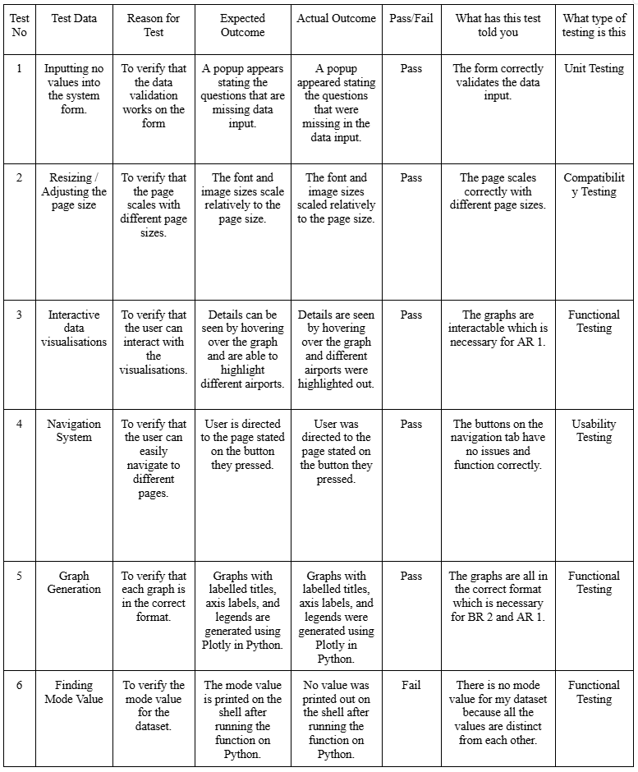

Outcomes, based on the testing that you have done have you made any changes? If so, explain them

The Tests from 1 to 5 all passed with demonstrated the correct functionality of the form validation, graph interactivity, navigation system, and graph generation. Test 6, which aimed to get the Mode Value, failed. This was due to the fact that all the values were distinct from each other, therefore no mode value is present.

No further changes to the system were necessary following the testing as all showed positive results. This shows that the website is performing as expected and is ready for submission.

Problem you have encountered - including screenshots of code - fully explain this

- Generating a presentable Bar Graph:
Using the code shown below I was able to generate the graph, also shown below. However the graph is clearly hard to understand and analyse. The values of each airport are on top of each other which wouldn’t make it presentable either for a user on the website.
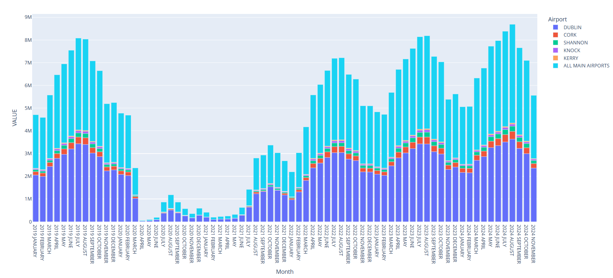

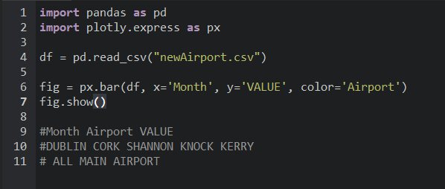

I tried finding different ways to make it so Plotly reads only the values of a certain airport. Below is one of the ways I tried to get Plotly to read the passenger values for Dublin Airport only but this way of overcoming the problem only gave me errors as shown.

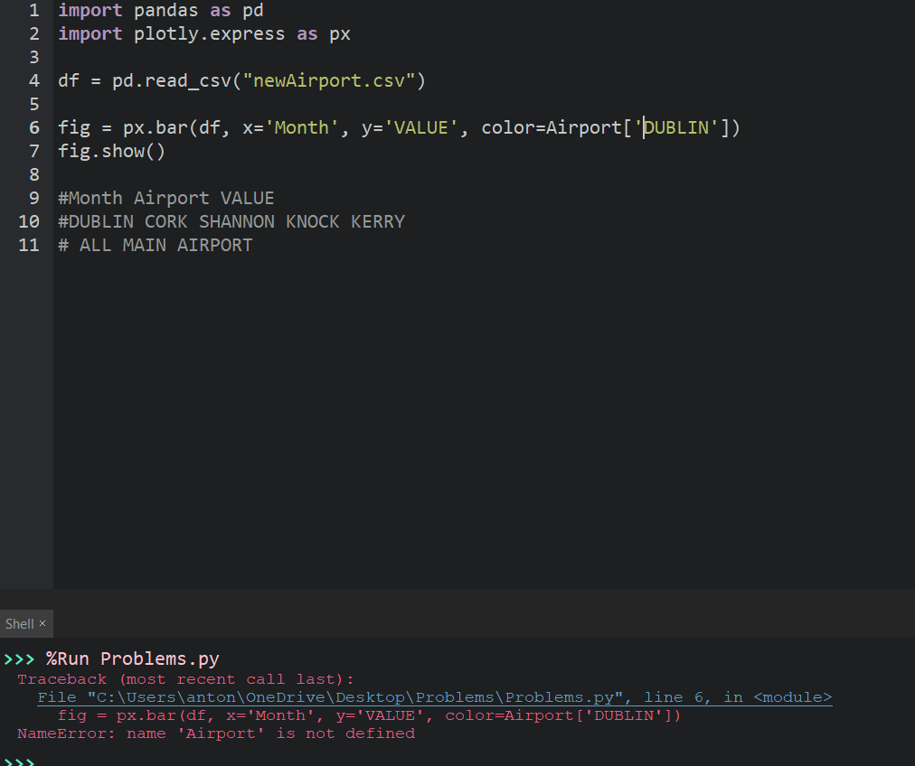

How you overcame the problem you encountered - including screenshots of code - fully explain this

- Generating a presentable Bar Graph:
How I overcame this problem was by figuring out that by creating a CSV File containing only the passenger values of one airport, I would be able to generate a suitable graph for analysing and presenting on my website.

First off I improvised my dataset cleaning code on Python as shown below. Using a For Loop I can check every row under the title ‘Airport’. Inside the loop is a counter which is to keep count of which row I am on. The if statement checks if the value of the row is equal to the string, the string is all the values under the title ‘Airport’ excluding one one value which is the value you want to keep and save as a CSV File. If the row name is equal to the string, the row is removed from the dataset and the counter is subtracted by 1 to stay on track on which row it is on. The new dataset is then saved into a CSV File. You repeat the code again but change the string in the if statement and the name of the CSV File at the bottom.

This was the most efficient solution I could think of into creating multiple CSV Files without taking a lot of time.

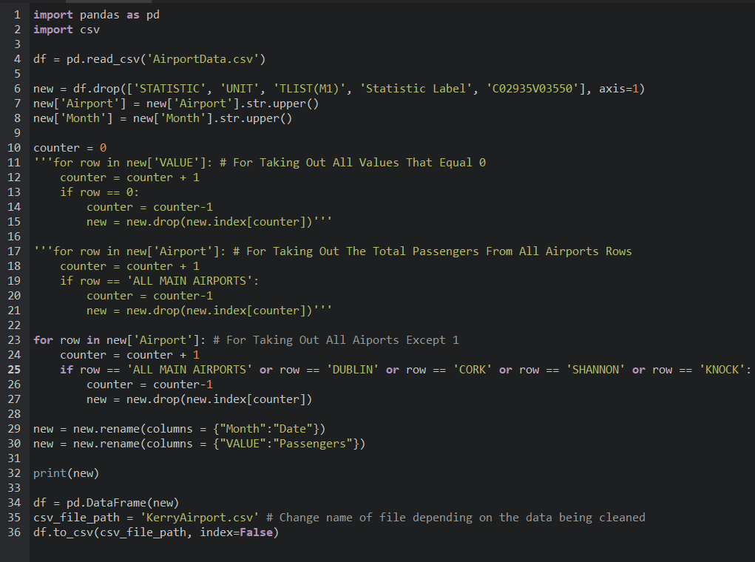

I found that changing the CSV File for each pd.read_csv(‘...’) and the name of the saved HTML File would take up a lot of time. I created a code shown below that uses a For Loop to go through a list containing the airport names. For each loop, the pd.read_csv(‘..’) reads a different airport which allows me to generate and save the Bar Graph for each airport in one click. With the use of f”{}...” I am able to input variables into a string which is the key to getting this code to work successfully.

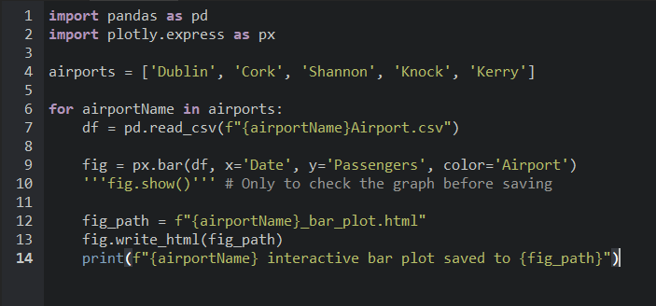

This example of the Bar Graph for Dublin Airport only is more readable for analysing and presentable for the website.
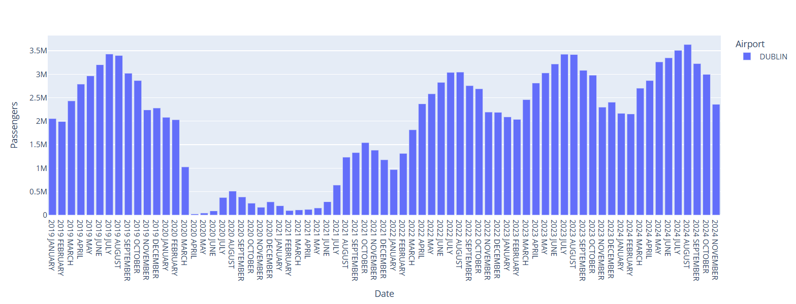

Clearly explain the algorithm you used for the analytics part of the project (mean, mode, median, standard deviation, min, max etc.)

The algorithms I created calculates the following statistics from my dataset and stores it into a dictionary efficiently.

- Peak ( Max ): The peak_value function finds the maximum number of passengers from the ‘Passengers’ column in the CSV File. It uses the max() function.

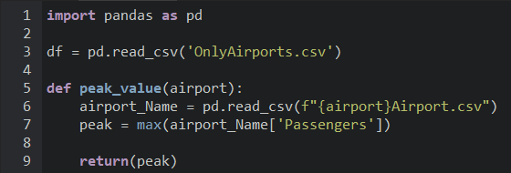

- Lowest Value ( Min ): The lowest_point function finds the minimum numbers of passengers from the ‘Passengers’ column in the CSV File. It uses the min() function.

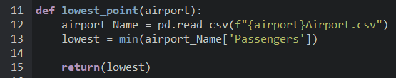

- Mean: The mean_calculator function calculates the average number of passengers from the ‘Passengers’ column. It uses the mean() function from Pandas and rounds the result to the nearest whole number.

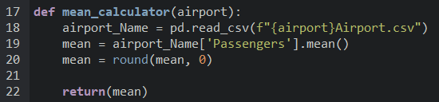

- Median: The median_finder function calculates the median number of passengers. It starts by storing all the values in a list. The list is then sorted using the sorted() function and a variable is created that contains the length of the list using the len() function. The if statement checks if the length of the list is Even or Odd. If length is Even then there are 2 medians, the two medians are located using indexing. They are added together, divided by 2 and rounded to a whole number. If length is Odd then the median is found by dividing the list length by 2 inside the index as shown.

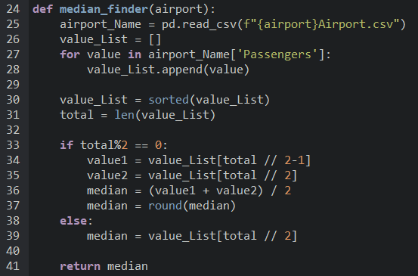

- Range: The range_finder function calculates the range of passengers by subtracting the minimum value from the maximum value using the min() and max() functions.

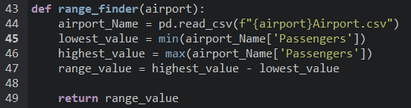

Write the pseudocode of the algorithm above - fully explain the entire algorithm

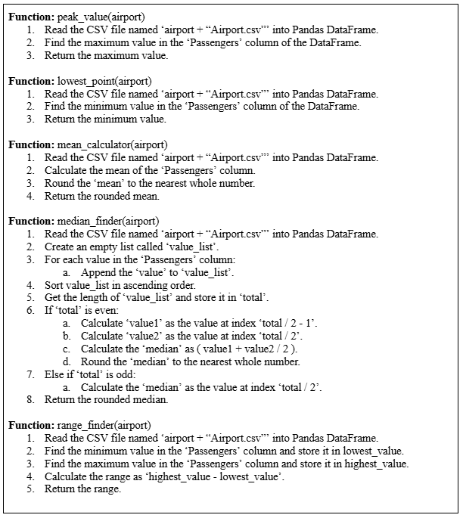

5. Evaluation (300 words - 8 marks)
Evaluate the final artefact and ensure it meets the requirements of the brief

- BR 1-
  - I successfully selected a suitable dataset based on passenger values in Irish Airports from the data.gov.ie website.
  - I extracted and cleaned the data using Pandas, and stored the cleaned data into a suitable format.

- BR 2-
  - I performed the required analytics, calculated statistics like the min, max, mean, median, and range and created at least two basic visualisations ( bar graph, line graph, etc. ) using Plotly.
  - My visualisations include clear labels and legends, making them easy to understand.
  - I made a Python dictionary ( airportDictionary ) to manage and organise the data.

- BR 3-
  - I developed a web-based interface using HTML, CSS, and JavaScript, providing a user-friendly way to view and interact with the data.
  - I successfully embedded the visualisations into my web interface, allowing users to view the data.

- AR 1-
  - I implemented interactive features ( Hover for details, legend highlighting, etc. ) using Plotly, enhancing the user experience on the web interface.

- AR 2-
  - I created a form with at least 3 different appropriate data types to collect additional information from users.
  - I implemented a data validation to ensure data quality and to store data securely in a database.
  - I summarised the collected data and displayed it in a clear and concise manner within the web interface.

- AR 3-
  - I developed sections on the web interface that provides data-driven recommendations related to Irish Airports.

Suggest how you can explain how the artefact can be improved or iterated upon in the future - if you had more time, more skill etc.

More Time / Skill:
- I would look into making my web interface more user friendly, especially those with disabilities. Things like a button to change font size for people with poor sight and a button to change the colour contrast of the web for people with colour blindness.

- I would implement simulations which will be able to predict outcomes on Irish Airports based on certain situations. Using the information I made about COVID-19, predicted outcomes can be made for future pandemics.

